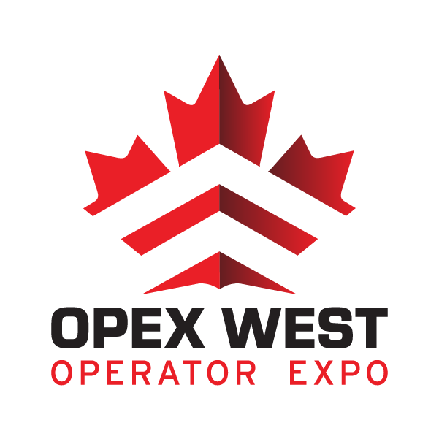

**Exhibitor Information Package**

Thank you for registering to attend OPEX West, 2-3 November 2022, at the Delta Burnaby Hotel and Conference Centre, 4331 Dominion Street, Burnaby, BC, V5G1C7 (DBHCC) as an Exhibitor! Within this package you will find the necessary information to make your OPEX experience a positive one. If updates are necessary, they will be pushed out to all registered exhibitors/vendors in a timely manner so that there are no surprises for anyone. Please email the OPEX Registrar at [info@operatorexpo.com](mailto:info@operatorexpo.com) with any questions regarding any aspect of the show. The Registrar will respond to routine queries within 48 hours. For urgent matters needing immediate response please email the Registrar at [patrick@tyrtactical.com](mailto:patrick@tyrtactical.com). The first two OPEX events in Ottawa were a success so we have decided to bring OPEX out to the West Coast. Reach out to all of your clients and let them know that OPEX West will take place, especially those clients located in Western Canada.

**Exhibitor Registration Online:**

Registration link for Exhibitors to make booth selection and payment is done through MapDynamics at the following link:

<https://shows.map-dynamics.com/opexwest2022/?register>

**Attendee Registration Link:**

When messaging clients about OPEX West, please point them to:

<https://form.jotform.com/213253897051053>

**Exhibitor Pricing:**

|  |  |  |
| --- | --- | --- |
| **OPEX Item Pricing** | | |
| **Item** | **Cost** | **Remarks** |
| Booth Interior 10' x 10' or 10’ x 8’ | 1500.00 CAD | Select during registration |
| 15 AMP Dedicated Circuit | 150.00 CAD | Select during registration |
| Shared Table Power | 50.00 CAD | Select during registration |
| Additional Meals per meal | 35.00 CAD | Select during registration |
| * All pricing options include taxes, due to facility configuration some booths  are 10’ x 8’. | | |
|  |  |  |
|  |  |  |

**Booth Selection**

There will be a combination of 38 interior 10’x10’ and 10’ x 8’ booths available to be booked for OPEX West 2022, layout is in accordance with the show map found at the registration link. Booth selection will be on a first come, first served basis. OPEX West may reassign, re-allocate booth space, or alter the event layout at any time. If there are specific requests for accommodation due to booth configuration, proximity to water supply and power, notify the Registrar ASAP so that an alternate solution can be considered.

**Payment and Terms**

Once online registration is completed, all payments to be made by cheque and/or Direct Funds Transfer. **Terms will be NET30 once booth selection is complete**. If payment terms are not met the booked booths will become open for selection and the Exhibitor will lose their selection. Please make cheques payable to “OPEX” and send to:

Attn: OPEX Registrar

134 Braddock Private

Ottawa ON

K2J0E6

**Cancellation Policy**

OPEX West reserves the right to cancel any booth selections and withdraw admission to facilities if payment terms are not met. No refunds will be granted should an Exhibitor/Vendor cancel any portion of their initial booking after 15 September 2022.

**Attendance and On-Site Registration**

Upon arrival to OPEX West all Vendors/Exhibitors are required to check in at the registration desk where they will be processed and issued their Exhibitor passes. The OPEX Registrar will require basic details of all personnel attending OPEX West in order to create Exhibitor passes in a timely manner. Exhibitors are requested to send the full name and title of each individual attending OPEX on behalf of the exhibitor no later than 01 October 2022. Please send this to:

[patrick@tyrtactical.com](mailto:patrick@tyrtactical.com)

All Exhibitors will have a unique pass indicating their status as an exhibitor, name, and agency. For those who do not register beforehand there will be blank passes available upon producing appropriate identification credentials.

**OPEX West Venue Address**:

Delta Hotels Burnaby Conference Centre

4331 Dominion Street,

Burnaby, BC

V5G1C7

**Exhibitor Shipping Instructions**:

The Delta Hotels Burnaby would be pleased to receive and assist in the handling of packages in advance

of your event. Due to the limited storage on property, they can only accept shipments 1 business day

prior to your function unless special storage arrangements have been made. Weekend deliveries require

advance coordination for loading bay access, as well as pallets and oversized items. Please forward requests for assistance in scheduling loading bay access for load in and load out to the OPEX West Registrar.

Delta Hotels Handling Fees

Services Include: Handling of packages at loading bay during business hours (Monday through Friday,

8:00 am to 4:30 pm) and delivery to your function room.

* Boxes (under 30 lbs each) – $5 plus tax per box
* $75 plus taxes per palette each way ($150 round trip)
* Shipping assistance (boxing, labelling, packing) - $35/hour labour (includes tape and plastic

wrap)

Please address all packages in the following manner:

Delta Hotels Burnaby Convention Centre -- Shipping Receiving Department

c/o your company (or Event Name), Event Manager Name, and date of function, meeting room

4331 Dominion Street

Burnaby, BC V5G 1C7

(Box 1 of 3)

POLICIES:

* Packages must be received through the loading dock and transported through the freight

elevators. Items received must not exceed 7’ tall by 5’ wide by 5’deep.

* Hotel will not receive packages through the front desk.
* Hotel will not receive or sign Cash-On-Delivery packages (C.O.D shipments), or be responsible

for international duties. We recommend using a customs broker for international shipments.

* Outbound shipments require online waybills provided by the shipper, once packaged the Event

Services Attendants will collect your package, and store with receiving for shipping the following

business day. Please ensure the provider and waybills are clearly marked on the packages.

* Any packages left for more than 48 hours after an event, will be subject to freight storage fees by a third party vendor as your packages will no longer be stored on property.

LIABILITY:

The hotel is not responsible for damage to, or loss of, any articles left on the premises during or following an event. Any packages that remain in the function room past the contracted function rental time will be subject to Forced Freight, and applicable charges will apply by our preferred partner.

Packages received more than 1-day prior to your event will be subject to storage fees or turned away if

locked storage is unavailable and not pre-arranged. Please contact your Event Manager in advance to

coordinate.

Shipping and Receiving Department at (604) 453-0768. Hours of operation: Monday through Friday, 8:00

am to 4:30 pm.

**Hotel Accommodation**

DBHCC Guest Rooms and Room Rate:

|  |  |  |  |  |
| --- | --- | --- | --- | --- |
| **Date** | **Day** | **King** | **Single/Double Rate** | **Total Rooms** |
| 10/31/2022 | Mon | 30 | $149.00 | 30 |
| 11/01/2022 | Tue | 60 | $149.00 | 60 |
| 11/02/2022 | Wed | 60 | $149.00 | 60 |
| 11/03/2022 | Thu | 30 | 149.00 | 30 |

Guestroom rates are subject to 8% PST and 5% GST, and 2% Hotel Room Tax.

Taxes are subject to change without notice.

**\*** Method of Reservations: Call 604-453-0750 or 800-268-1133 prior to September 30, 2022 (Cut-off date) and mention the name of the event “OPEX West Nov2022” to get the above listed rates.

**Sequence of Events**:

Below table gives a rough timeline from the booth set up day through to the last day of OPEX. The upper pavilion of the ICC can be made available if there is a training event incorporated into the show (update will be pushed out indicating this closer to the event).

|  |  |  |  |  |
| --- | --- | --- | --- | --- |
| **OPEX West 02-03 Nov 2022** | | | | |
| **Time** | **Booth Set Up Day – 01 Nov 2022** | **Day 1 – 02 Nov 2022** | **Day 2 – 03 Nov 2022** | **Remarks** |
| **0800-0900** | Booth Set Up | Exhibitor Prep | Exhibitor Prep | Venue open as of 0800 for Vendor preps |
| **0900-1200** | Booth Set UP | OPEX West Show | OPEX West Show |  |
| **1200-1300** |  | Lunch | Lunch | Exhibitor lunch on day 2 and 3 only |
| **1300-1500** | Booth Set Up | OPEX West Show | OPEX Show |  |
| **1500-1600** | Booth Set Up | OPEX West Show | Tear Down |  |
| **1700-2100** | Booth Set Up | End Day One | OPEX Complete | Clear of Venue in accordance with Shipping Receiving Instructions |

**Amenities**:

**Meals** - There will be lunch each day for all registered Exhibitors only (2 meals per booth included in booth cost). For additional meals Exhibitors must select this option during registration. All Exhibitors must forward a list of their representatives attending OPEX West 2022 to the Registrar ([patrick@tyrtactical.com](mailto:patrick@tyrtactical.com)) No later than 01 Oct 2022.

**WIFI** – Complimentary WIFI in guestrooms and meeting space

**Parking** - Self Parking is Complimentary, Valet Parking 16.00/day; 22.00/overnight

**Booth Composition** - 6’ table w/cloth, 2 chairs, small garbage can. Booths will have dividers that can be removed as and when required. If booth power is required it should be selected during registration.

**Casino** – Destination casino on the resort

**Shuttle Service** – Shuttle service available within a 10 km radius

**DBHCC Map**:

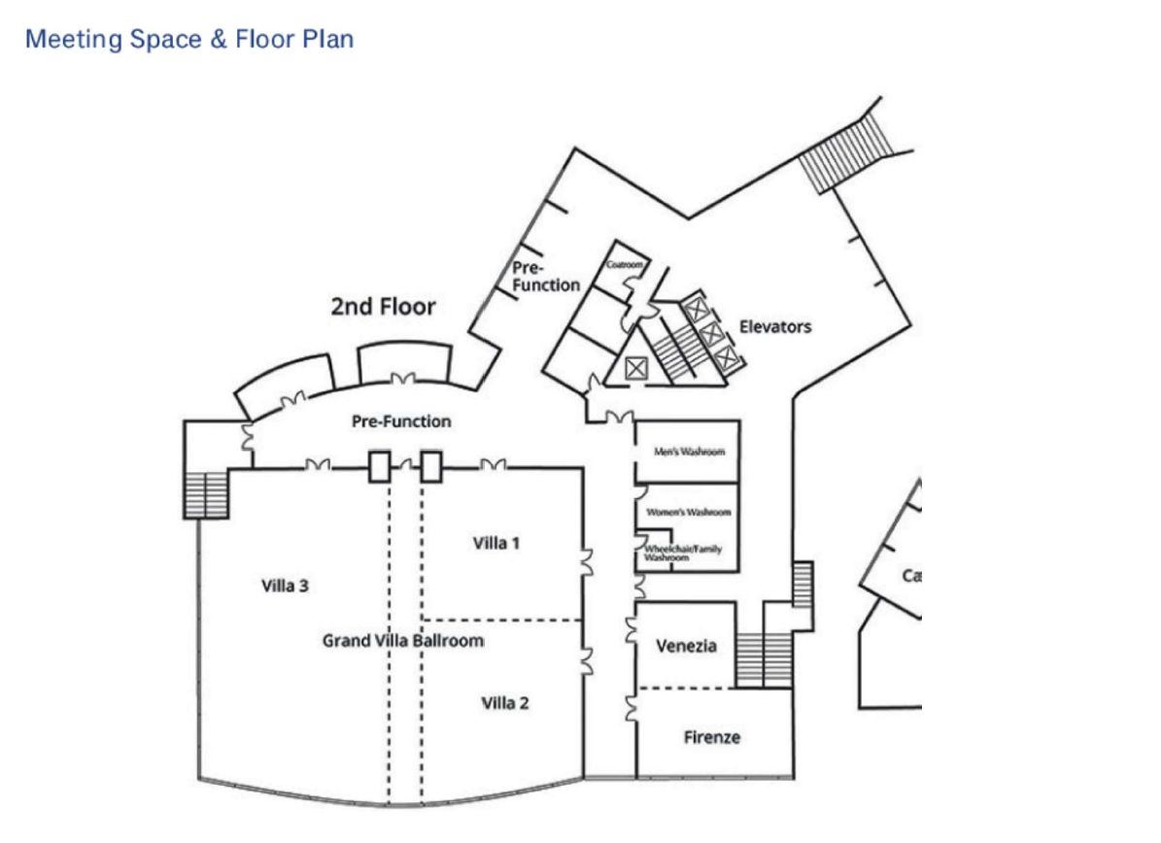

**Booth Layout**:



**COVID-19**:

**Main Entrance**

All guidelines recommended and laid out by the BC Ministry of Health will be followed. Hand sanitizer and disposable masks will be available during the event.

**Continued Updates**

At any time, if there are any questions about any aspect of the event, do not hesitate to reach out to the OPEX Registrar at [patrick@tyrtactical.com](mailto:patrick@tyrtactical.com). Updates will be pushed out to registered Exhibitors as things change with potential to impact the event.

**Marketing**

OPEX West will conduct a marketing campaign leading up to the event but in order to ensure the most successful event possible, Exhibitors are requested to use their social media presence to get the word out to their clients, and product line representatives.

During the registration process there will be a link available for vendors to go to where they can fill in the marketing package to be used to highlight company profiles during the Marketing Campaign leading up to the event.